Task 1: Write the following assembly program in editor and execute it

|  |  |  |  |  |  |  |  |  |
| --- | --- | --- | --- | --- | --- | --- | --- | --- |
| Instruction | AH | AL | BH | BL | DH | DL | CL | CF |
| MOV AX,1456 | 05 | B0 | 0 | 0 | 0 | 0 | 0 | 0 |
| MOV BX,0FF00H | 0 | 0 | FF | 0 | 0 | 0 | 0 | 0 |
| XOR AX, AX | 00 | 00 | 0 | 0 | 0 | 0 | 0 | 0 |
| MOV BX,2300H | 0 | 0 | 23 | 00 | 0 | 0 | 0 | 0 |
| MOV DS, BX | 0 | 0 | 23 | 00 | 00 | 0 | 0 | 0 |
| MOV [1601H],25H | 0 | 0 | 23 | 0 | 0 | 0 | 0 | 0 |
| OR BH, [1601H] | 0 | 0 | 27 | 0 | 0 | 0 | 0 | 0 |
| MOV CL,3 | 0 | 0 | 27 | 0 | 0 | 0 | 03 | 0 |
| MOV DX,23DCH | 0 | 0 | 27 | 0 | 23 | DC | 03 | 0 |
| SHL DX, CL | 0 | 0 | 27 | 0 | 1E | E0 | 03 | 0 |
| SHR DX,3 | 0 | 0 | 27 | 0 | 0F | 70 | 03 | 0 |
| SAL DX,1 | 0 | 0 | 27 | 0 | 07 | B8 | 03 | 0 |
| MOV AH,250 | 0 | 0 | 27 | 0 | 07 | B8 | 03 | 0 |
| ADD AH,10 | FA | 0 | 27 | 0 | 07 | B8 | 03 | 0 |
| RCR AH,2 | 04 | 0 | 27 | 0 | 07 | B8 | 03 | 0 |
|  |  |  |  |  |  |  |  |  |
|  |  |  |  |  |  |  |  |  |

Task 2: Write and assembly program to count the number of 1’s

Write an assembly language program that counts the number of ‘1’s in a byte residing in CL

register. Store the counted number in DH register.

mov dh, 00h

mov cl ,10101011b

rol cl,1

adc dh,00

rol cl,1

adc dh,00

rol cl,1

adc dh,00

rol cl,1

adc dh,00

rol cl,1

adc dh,00

rol cl,1

adc dh,00

rol cl,1

adc dh,00

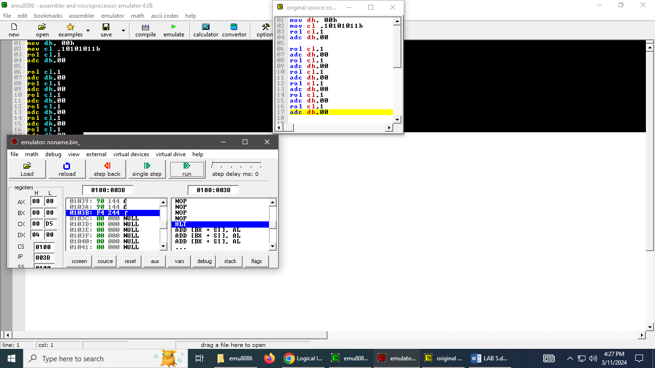

Task 3: Bits’ manipulation

Write an assembly language program to perform the following tasks:

1. Set the leftmost 4 bits of AX

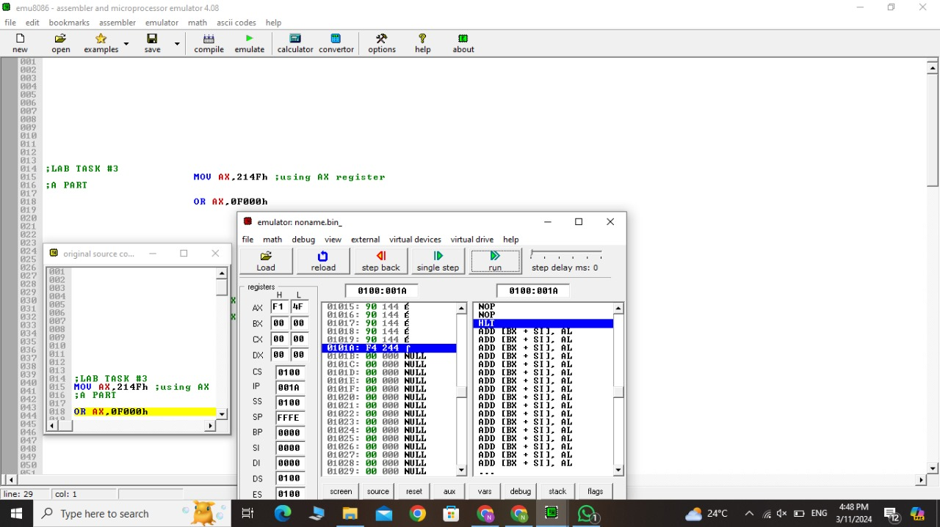

b most 3 bits of AX

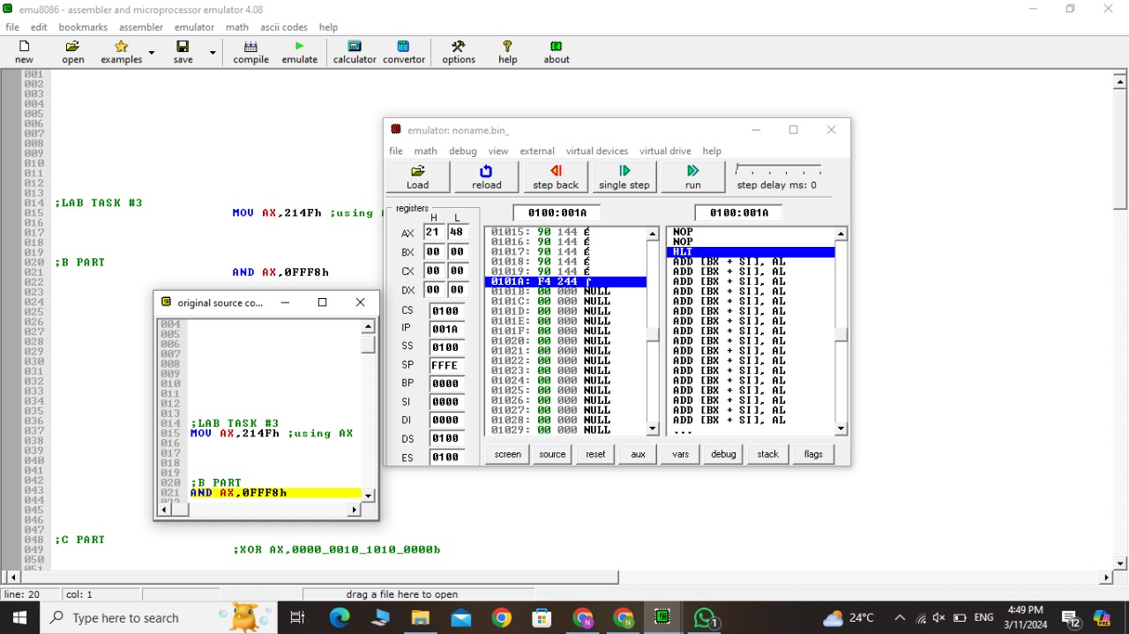

C Invert the bits 5,7and 9 of AX.

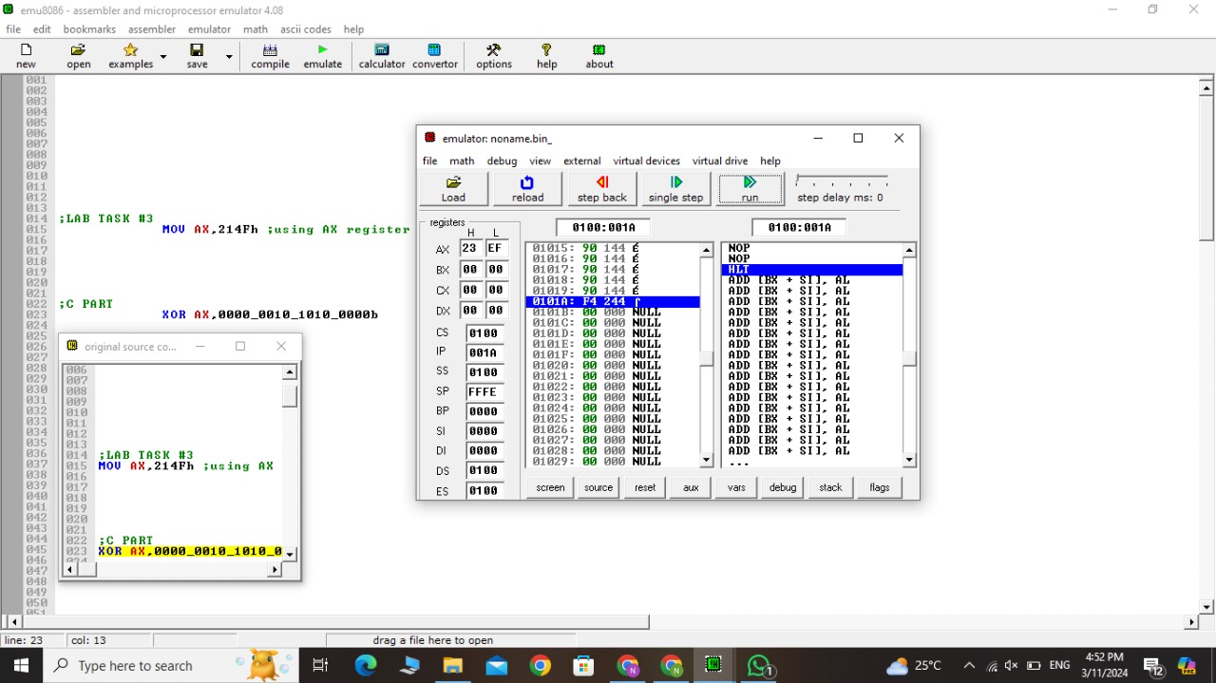

Task 4: Bits’ masking

Write an assembly language program that clears any bit (from bit0 to bit15) in AX register,

leaving other bits unchanged. Number of bits that is to be cleared is stored in CL register.

